Personal Information

Name ____________________________________________________________

Address ____________________________________________________________

Phone (home)_________________(work)__________________(other)______________

OHIP# with version code___________________________________________________

DOB(day, month, year)____/____/_____ Age _______ Height _______ Weight _______

WSIB: Yes____ No ____ If Yes: WSIB claim#_______________________________

Date of injury______________ Employer at time of injury________________________

Family Physician (name)____________________________(phone)__________________

Extended Health Insurance Y or N

Pharmacy (name, location)__________________________________________________

(phone) _____________________________(fax)________________________________

Emergency contact name___________________________________________________

Relationship to patient_____________________________________________________

Phone(home)___________________________(work)____________________________

Current Pain Diagnosis

Past Medical /Surgical History

Allergies

Social History

Marital Status: Single____Common Law____Married ____ Children_______________________

Employed Y_____N_____ Current Job__________________________________________

Missed work days/week _______________ Jobs lost due to illness_________________________

Smoker Y_____N_____ Packs/day _______ Years smoked__________

Alcohol Y_____N_____Drinks/week_______ Max Drinks/day_______

Street Drugs Y_____N_____ Types_________________________________________

Caffeine ________cups/day Regular Exercise Y_____N_____

Family History(check all that apply)

Heart disease |  | Diabetes
Cancer |  | Mental illness
Alcohol or drug abuse
Bleeding disorders
Arthritis

Current Medications

Medication Dose Schedule
Previously tried Treatments (check all that apply)

Physiotherapy |  | Mindfulness based stress reduction
Massage therapy |  | Acupuncture
Chiropractor |  | Nerve and trigger point blocks
Pain self management |  | Multi-disciplinary Pain Program
Psychological therapy

Previously tried Medications (check all that apply)

Acetaminophen (Tylenol) |  | Tramadol (Tramacet)
NSAID/COXIB (Ibuprofen, Celebrex, etc) |  | Tramadol long acting(Zytram XL, Ralivia,Tridural)
Amitriptyline, Nortriptyline, Desimpramine |  | Codiene(Tylenol 1,2,3,4)
Citalopram, Fluoxetine, Fluvoxamine, Paroxetine, Sertraline (Celexa, Paxil, etc) |  | Codiene long acting(Codiene Contin)
Venlafaxine, Duloxetine(Effexor, Cymbalta) |  | Oxycodone (Percocet)
Carbamazepine |  | Oxycodone long acting(Oxycontin, OxyNeo, Targin)
Valproic Acid |  | Morphine
Gabapentin(Neurotin) |  | Morphine long acting(MS Contin, MEslon, Kadian)
Pregablin(Lyrica) |  | Hydromrophone(Dialudid)
Topiramate(Topomax) |  | Hydromorphone long acting (Hydromorphcontin)
Nabilone (Cesamet) |  | Fentanyl (Duragesic)
Medical Marijuana |  | Methadone
Topical Pain Medication |  | Buprenorphrine(BuTrans)
Zanaflex, Bacolfen, Flexeril |  | Tapentadol (Nucynta)
Brief Pain Inventory – Modified

On the diagram below, shade in the areas where you feel pain. Put an X on the areas where it hurts the most.
(S= sharp /stabbing, B=burning, N=numbness, P=pins and needles, A=aching, Arrows=shooting pain)
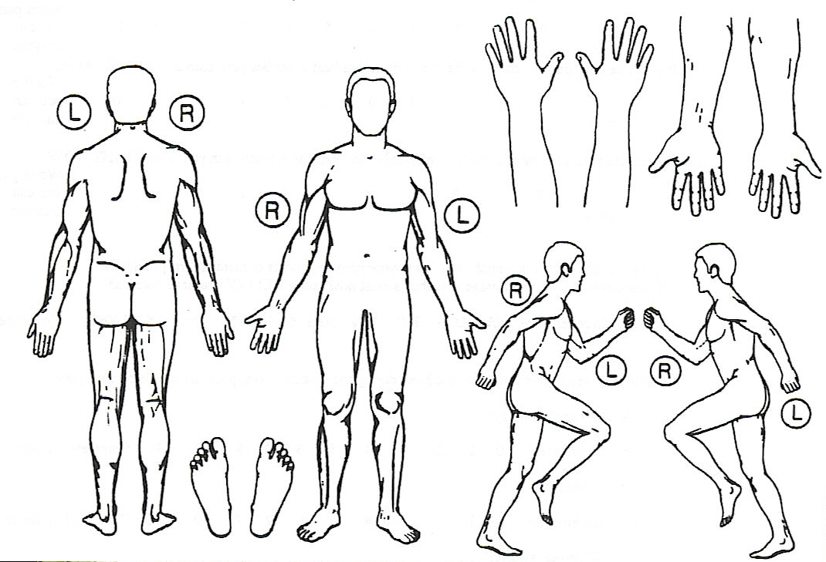
What things make your pain feel worse?

What things make your pain feel better?

What are your treatment goals for your pain?

Please rate your pain by circling the number that best describes your pain at its WORST in the past 24 hours.

No Pain 0____1____2____3____4____5____6____7____8____9____10 Worst Pain

Please rate your pain by circling the number that best describes your pain at its LEAST in the past 24 hours.

No Pain 0____1____2____3____4____5____6____7____8____9____10 Worst Pain

Please rate your pain by circling the number that best describes your pain at its AVERAGE in the past 24 hours.

No Pain 0____1____2____3____4____5____6____7____8____9____10 Worst Pain

Please rate your pain by circling the number that tells how much pain you have RIGHT NOW.

No Pain 0____1____2____3____4____5____6____7____8____9____10 Worst Pain

With permission: Pain Research Group
MD Anderson Cancer Center, 1997

DN4

Does the pain have one or more of the following characteristics? YES NO

Burning ………………………………………………………………… [ ] [ ]
Painful sensation of Cold..……………………………………………… [ ] [ ]
Electric Shocks.………………………………………………………… [ ] [ ]

Is the pain associated with one or more of the
following symptoms in the same area? YES NO

Tingling………………………………………………………………… [ ] [ ]
Pins and Needles..……………………………………………………… [ ] [ ]
Numbness…….………………………………………………………… [ ] [ ]
Itching ..………………………………………………………………… [ ] [ ]

For Clinic Use

Hypoesthesia to touch…………………………………………………… [ ] [ ]
Hypoesthesia to pinprick………………………………………………… [ ] [ ]
Painful brushing………………………………………………………… [ ] [ ]

SCORE: _________ ________ Positive

Bouhassira D, et al. 2005

Pain Disability Index (PDI)

The rating scales below are designed to measure the degree to which aspects of your life are disrupted by chronic pain. In other words, we would like to know how much your pain is preventing you from doing what you would normally do, or from doing it as well as you normally would. Respond to each category by indicating the overall impact of pain in your life, not just when the pain is at its worst.
For each of the seven categories of life activity listed, please circle the number on the scale, which describes the level of disability you typically experience. A score of zero means no disability at all, and a score of 10 signifies that all of the activities in which you would normally be involved in have been totally disrupted or prevented by your pain.

Family/ home responsibilities: This category refers to activities related to the home or family. It includes chores or duties performed around the house (e.g., yard work) and errands or favours for other family members (e.g., driving the children to school).

No Disability 0____1____2____3____4____5____6____7____8____9____10 Worst Disability

Recreation: This category includes hobbies, sports and other similar leisure time activities.

No Disability 0____1____2____3____4____5____6____7____8____9____10 Worst Disability

Social Activity: This category refers to activities which involve participation with friends and acquaintances other than family members. It includes parties, theatre, concerts, dining out, and other social functions.

No Disability 0____1____2____3____4____5____6____7____8____9____10 Worst Disability

Occupation: This category refers to activities that are a part of, or are directly related to one’s job. This includes non-paying jobs such as that of a home-maker or volunteer work.

No Disability 0____1____2____3____4____5____6____7____8____9____10 Worst Disability

Sexual Behaviour: This category refers to the frequency and quality of one’s sex life.

No Disability 0____1____2____3____4____5____6____7____8____9____10 Worst Disability

Self-Care: This category includes activities, which involve personal maintenance and independent daily living (e.g., taking a shower, driving, getting dressed, etc.)

No Disability 0____1____2____3____4____5____6____7____8____9____10 Worst Disability

Life-support Activity: This category refers to basic life-supporting behaviours such as eating, sleeping and breathing.

No Disability 0____1____2____3____4____5____6____7____8____9____10 Worst Disability

For Clinic Use

Score: _______ ________ Mild
________ Moderate
________ Severe
Patient Health Questionnaire-9 (PHQ-9)
This questionnaire is an important part of providing you with the best health care possible. Your answers will help in understanding problems that you may have. Please answer every question to the best of your ability.

Over the last 2 weeks, how often have you been Not Several More than Nearly
bothered by any of the following problems? at all days half the days every day
a. Little interest or pleasure in doing things [ ] [ ] [ ] [ ]
b. Feeling down, depressed, or hopeless [ ] [ ] [ ] [ ]
c. Trouble falling or staying asleep, or sleeping too much [ ] [ ] [ ] [ ]
d. Feeling tired or having little energy [ ] [ ] [ ] [ ]
e. Poor appetite or overeating [ ] [ ] [ ] [ ]
f. Feeling bad about yourself - or that you are a failure or
have let yourself or your family down [ ] [ ] [ ] [ ]
g. Trouble concentrating on things, such as reading the
newspaper or watching television [ ] [ ] [ ] [ ]
h. Moving or speaking so slowly that other people could have
noticed? Or the opposite - being so fidgety or restless that
you have been moving around a lot more than usual [ ] [ ] [ ] [ ]
i. Thoughts that you would be better off dead or of
hurting yourself in some way [ ] [ ] [ ] [ ]

For Clinic Use

SCORE: ____________ ________ Mild
________ Moderate
________ Moderately Severe
________ Severe

Spitzer, RL et al, 1999

Generalized Anxiety Disorder 7 Item Scale (GAD-7)
This questionnaire is an important part of providing you with the best health care possible. Your answers will help in understanding problems that you may have. Please answer every question to the best of your ability.

Over the last 2 weeks, how often have you been Not Several More than Nearly
bothered by any of the following problems? at all days half the days every day
a. Feeling nervous, anxious, or on edge …………………………... [ ] [ ] [ ]
b. Not being able to stop or control worrying [ ] [ ] [ ] [ ]
c. Worrying too much about different things [ ] [ ] [ ] [ ]
d. Trouble relaxing [ ] [ ] [ ] [ ]
e. Being so restless that it’s hard to sit still [ ] [ ] [ ] [ ]
f. Becoming easily annoyed or irritable…………………………... [ ] [ ] [ ] [ ]
g. Feeling afraid as if something awful might happen…………….. [ ] [ ] [ ] [ ]

For Clinic Use

SCORE: ____________ ________ Mild
________ Moderate
________ Severe

Spitzer, RL et al, 2006
PCS

We are interested in the types of thoughts and feelings that you have when you are in pain. Listed below are some statements describing thoughts and feelings that may be associated with pain. Please check the number box which best represents the degree to which you have these thoughts and feelings when you are experiencing pain.

0 = not at all 1 = to a slight degree 2 = to a moderate degree 3 = to a great degree 4 = all the time

When I am in pain…. 0 1 2 3 4

I worry all the time about whether the pain will end
I feel I can’t go on
It’s terrible and I think it’s never going to get any better
It’s awful and I feel it overwhelms me
I feel I can’t stand it any more
I become afraid that the pain will get worse
I keep thinking of other painful events
I anxiously want the pain to go away
I can’t seem to keep it out of my mind
I keep thinking about how much it hurts
I keep thinking about how badly I want the pain to stop
There is nothing I can do to reduce the intensity of the pain
I wonder whether something serious might happen

For Clinic Use

SCORE : _________ ________ Moderate Risk
________ High Risk

Sullivan et al 1995

PC-PTSD

In your life, have you ever had any experience that was so frightening, horrible, or upsetting, that in the past month you:

YES NO
Have had nightmares or thought about it when you didn't want to? [ ] [ ]

Tried hard not to think about it or went out of your way to avoid
situations that reminded you of it? [ ] [ ]

Were constantly on guard, watchful, or easily startled? [ ] [ ]

Felt numb or detached from others, activities, or your surroundings? [ ] [ ]

For Clinic Use

SCORE : __________ ________ Positive

Prins, A et al 2004
STOP BANG – Sleep Apnea

YES NO
Do you SNORE loudly (louder than talking or loud enough to be heard
through closed doors)? [ ] [ ]

Do you often feel TIRED, fatigued, or sleepy during daytime? [ ] [ ]

Has anyone OBSERVED you stop breathing during your sleep? [ ] [ ]

Do you have or are you being treated for high blood PRESSURE? [ ] [ ]

NECK circumference > 16 inches (40cm)? [ ] [ ]

For Clinic Use

BMI = ___________ >35 [ ] [ ]
Age >50 [ ] [ ]
Gender Male [ ] [ ]

SCORE:_________
________ Low Risk
________ Moderate Risk
________ High Risk

Chung, F et al, 2014

CAGE- AID

Please check any of the questions that apply to you.

In the past have you ever:

________1. felt that you wanted or needed to cut down on your drinking or drug use?
________2. been annoyed or angered by others complaining about your drinking or drug use?
________3. felt guilty about the consequences of your drinking or drug use?
________4. had a drink or taken a drug in the morning (eye opener) to decrease a hangover or
withdrawal symptoms?

For Clinic Use

SCORE:_________

_________ Low Risk
_________ High Risk

Ewing 1984

ORT
Check any box that applies to you
1.Family History of Substance Abuse:
Alcohol
Illegal Drugs
Prescription Drugs

2.Personal History of Substance Abuse:
Alcohol
Illegal Drugs
Prescription Drugs

3. Age:
Mark if your age is between 16-45

4. History of Preadolescent Sexual Abuse
Mark if this applies to you

5. Psychological Disease:
Attention Deficit Disorder, Obsessive-Compulsive Disorder, Bipolar, or Schizophrenia
Depression

For Clinic Use

SCORE:___________

____________ Low Risk
____________ Moderate Risk
____________ High Risk

Published with the permission of Lynn R. Webster, MD (2005)

